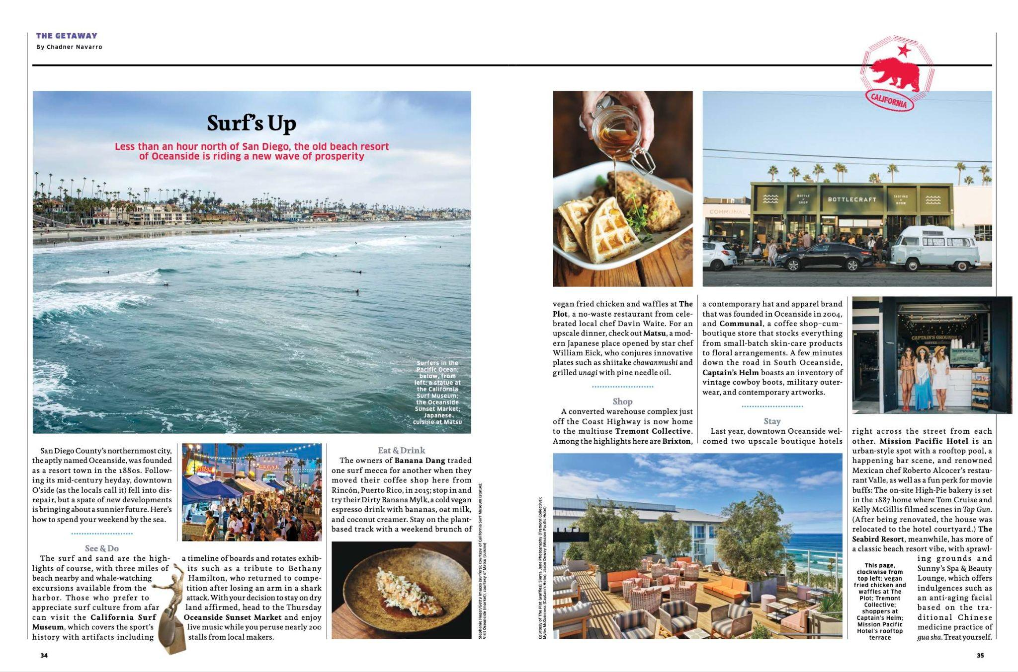

United Airlines HEMISPHERES—July 2022

